VOLUME with KNOWN CROSS-SECTIONS
Project

Name ____________________________________ PER _______ DATE ________________________

Calc 16.0: Students use definite integrals in problems involving area, velocity, acceleration, volume of a solid, area of a surface of revolution, length of a curve, and work.

This project can start in one of two ways:

- Draw the graph of a function (degree higher than 2) and make an
image using it.

OR

2) Draw an image and create a function whose graph fits its contour.

NEXT STEP: Choose which cross-sections you are going to use.
-SQUARES
-SEMICIRCLES
-EQUILATERAL TRIANGLES

THEN: Calculate the volume of each cross-section needed to fill the given area
under the graph. Show your work, nice and neat, and then add them
together.

ALMOST DONE: Find the volume of the same space using the integral formula.
(VIDEOS AVAILABLE FOR REFERENCE ON WEEBLY, WEEK 16!)

LAST BIG STEP: Draw your graph on foam core. Cut your cross sections out of cardboard and glue them standing up side by side. Color is required!

AND OF COURSE: Complete the reflection on the back of this page.

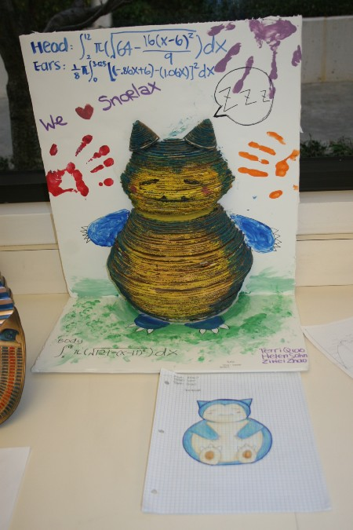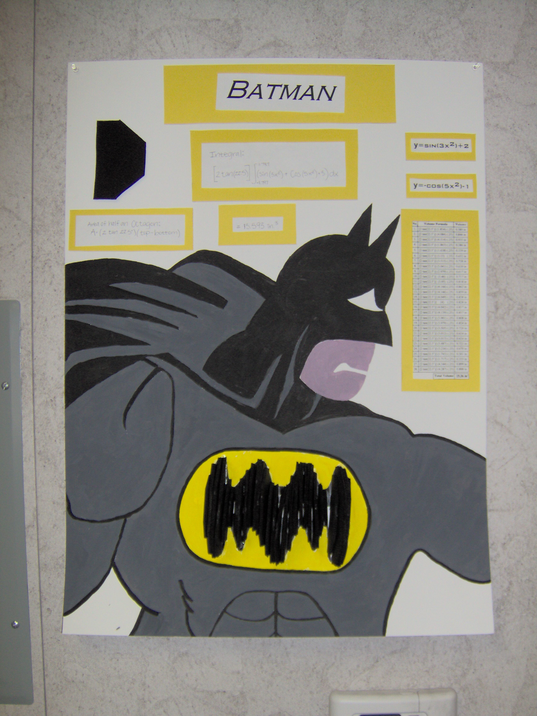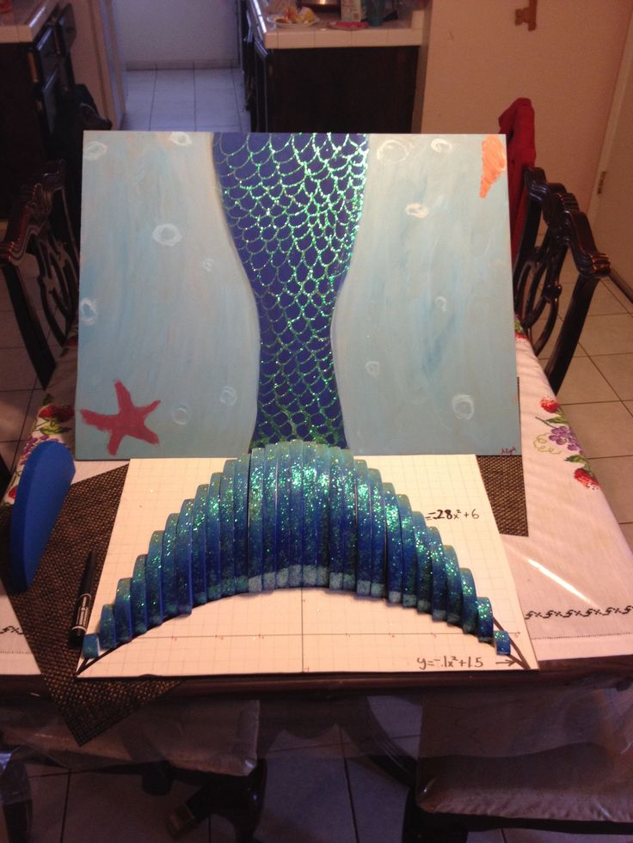
RUBRIC

 | 4 | 3 | 2 | 1
Neatness and completeness | Artwork is complete and has no ‘stray marks’ | Artwork is complete w/ some ‘stray marks’ | Artwork is complete, but very messy | Artwork is incomplete
Mathematical Work | Math Work shown is complete and accurate | Math Work shown is accurate, but missing a few elements | Math Work shown is accurate, but missing several elements | Math Work shown is inaccurate
Reflection I | Explanation is thorough, with no grammatical errors | Explanation is thorough, with some grammatical errors | Explanation is thorough, but several grammatical errors | Explanation is vague

- How close were your computations with the cardboard cross sections to your integral computation? If you were off by a lot, explain why you suppose that occurred.

- What Algebraic, Geometric, and Calculus skills were required to complete this project? Do you believe your mastery of these skills were strengthened by the end of the project? Explain your answer.

