ARC and IRC REVIEW!

Name _______________________________________________ PER_________ DATE__________________

In the previous lesson, you calculated the average rate of change of a function between two points. In this lesson, you will investigate what happens to the average rate of change between two points on a function when those two points get closer and closer together. You will also explore what average rate of change (AROC) tells you about a function.

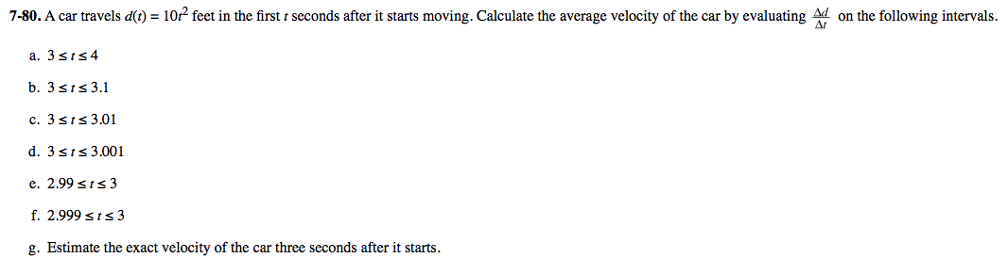

7-94. Let d(t) = 10t² feet continue to be the distance function with respect to time of the car from problem 7-80.

  - Calculate the average velocity of the car on the interval t = 5 to t = 5 + h where h is 0.5, 0.1, and 0.01.

  - What values are the same in each calculation? What values are changing?

  - What is happening to the value of h on this interval?

  - What is happening to the velocity of the car as the interval becomes smaller and smaller?

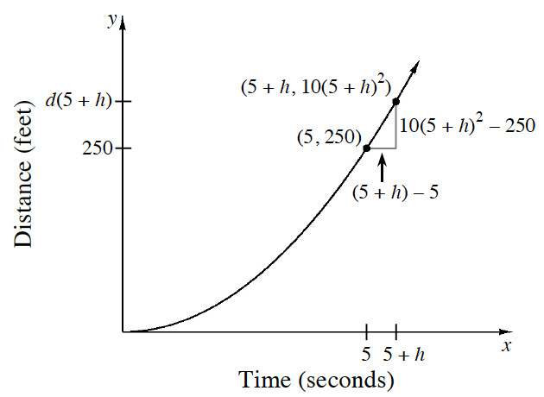

7-95. In the previous problem, h changed while t = 5 did not change. This causes repetition in your average velocity calculations. To simplify this process, complete the parts below to calculate the average velocity of the same car from t = 5 to t = 5 + h.

  - Write an expression for the average velocity of the car over the interval 5 ≤ t ≤ 5 + h. Simplify your result as much as possible and compare your result with your team.

  - Using your result from part (a), evaluate the average velocity of the car over the intervals 5 ≤ t ≤ 5.5, 5 ≤ t ≤ 5.1, and 5 ≤ t ≤ 5.01. How do your answers compare to the results of problem 7-94.

  - What does your answer from part (a) allow you to calculate?

7-96. Use the same distance function as in the previous problems: d(t) = 10t².
  - Write an expression for the average velocity from t = 4 to t = 4 + h.

  - Use your expression from part (a) to calculate the average velocity from t = 4 to t = 4.1, t = 4 to t = 4.01, t = 3.99 to t = 4, and t = 3.999 to t = 4.

7-97. In problem 7-90, the volume of the tube was V(x) = x²(12 − 4x). Sketch the graph of y = V(x) and calculate the slope over the following intervals:

  - 2 ≤ x ≤ 2.5

  - 2 ≤ x ≤ 2.1

  - 2 ≤ x ≤ 2.01

  - 2 ≤ x ≤ 2.001

  - 1.99 ≤ x ≤ 2

  - 1.999 ≤ x ≤ 2

  - What value is the slope approaching as the intervals in parts (a) through (f) become smaller? What does this value mean in terms of the volume of the tube?

7-98. Let R(t) be the altitude of a rocket t seconds after takeoff.

- Write the expression for the average velocity of the rocket from time t = 20 to time t = 20 + h in terms of R(t).

- As h gets closer and closer to 0, what happens to the average velocity of the rocket?

Complete the following problems in your PRACTICE NOTEBOOK, titled, “Day 18 – 7.2.3 Practice”

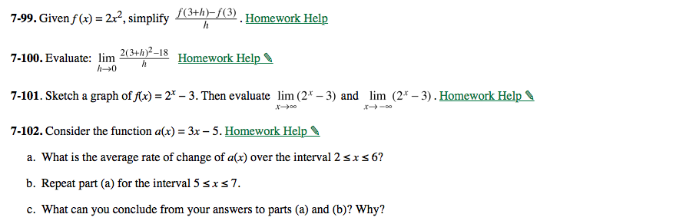

ARC and IRC REVIEW – Part 2

TPS-C

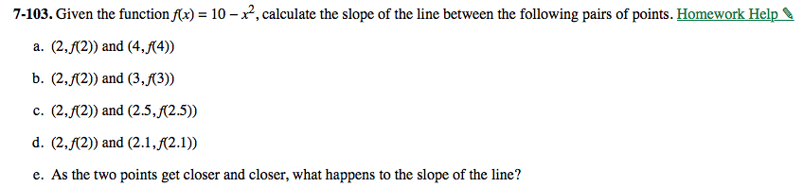

Draw the graph above and draw a line segment between each set of points listed in parts a.) through f.) in problem 103.

7-109. In the previous problem you calculated the slopes of the secant lines that passed through the given points. Now focus on the secant lines themselves. Obtain a Lesson 7.2.4 Resource Page and use it to investigate what happens to a secant line when h approaches 0.

  - On the Lesson 7.2.4 Resource Page use a colored pencil and a straight edge to draw a secant line through the points (2, f(2)) and (2 + h, f(2 + h)) where h = 1. Be sure to extend your line well beyond the points. With a different colored pencil draw another secant line through the points (2 − h, f(2 − h)) and (2, f(2)) where h = 1.

  - On the separate graphs, repeat the process from part (a) for h = 0.5, h = 0.25, and h = 0.1. Be sure to draw each secant line with the correct color and in the order given.

  - What is happening to the secant lines as h approaches zero?

7-110. When the value of h approaches zero the secant line approaches a tangent line. A tangent line is a line that “grazes” the curve at a single point. When this occurs, the average rate of change approaches an instantaneous rate of change (IROC), the exact slope of the function at a point. How are IROC and the tangent line at a point related?

7-111. Now, consider the function r(t) = 2t³.
  - Show that the average rate of change of r(t) from t = 2 to t = 2 + h is 24 + 12h + 2h².

  - Evaluate the limit as h → 0 for your expression from part (a).

  - Write a complete sentence describing what the answer from part (b) represents.

- 7-112. Given the function f(x) = 2^{x}.
  - Write an expression for the average rate of change of f from x = 5 to x = 5 + h.

  - What happens to this expression when h = 0? What does this tell you about the
instantaneous rate of change at x = 5?

  - Use a graphing calculator to evaluate 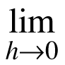 for the expression you wrote in part (a).

  - Do this by examining a table or a graph of the expression at values extremely close to h = 0.

  - What does this value represent?

7-113. In homework problem 7-102 you showed that the average rate of change for y = 3x − 5 is 3, no matter what interval is used. What is the average rate of change of any linear function? To investigate this, let f(x) = mx + b and complete the parts below.
- Explain why average rate of change is computed by using the ratio 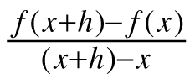.

- Evaluate the ratio from part (a) using f(x) = mx + b. Why does the result make sense? What have you proved?

Complete the following problems in your PRACTICE NOTEBOOK, titled, “Day 18 – 7.2.4 Practice”

