2.3 Homework

Name ______________________________ PER _______ DATE _______________________

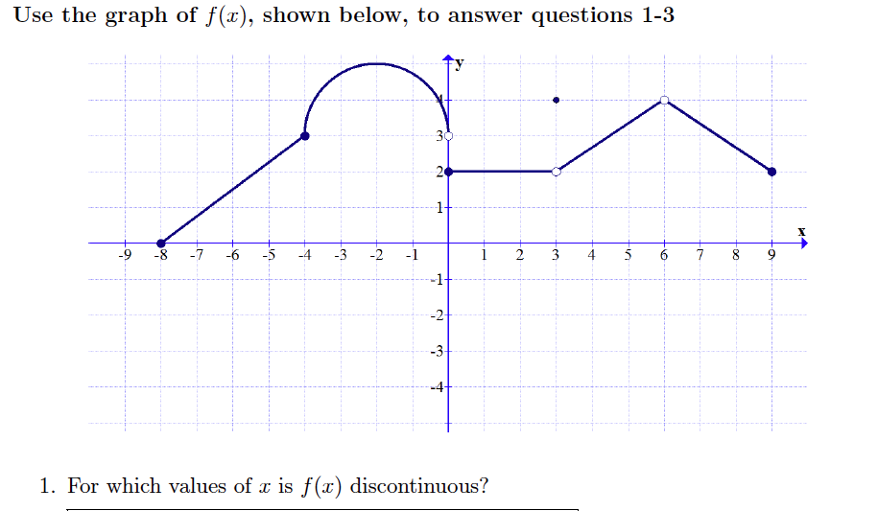

- [-8, -4] b.) [-2, 1]

- (3, 6) d.) [6, 9]
