2.2.a-b Homework

Name ______________________________________ PER ____________ DATE ____________________

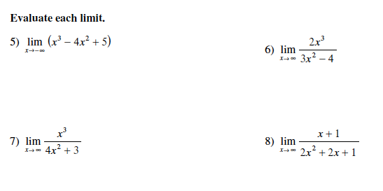

BC ONLY!

